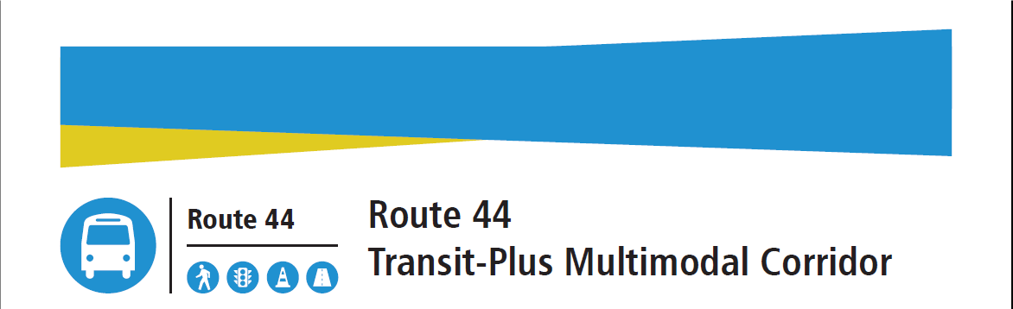

# **Online Presentation Talking Points *(survey/short presentation)***

**Slide 1: Intro slide**

*Thank you for your interest in the Route 44 Transit-Plus Multimodal Corridor Project.*

**Slide 2: Project background**

* *SDOT is partnering with King County Metro to improve transit reliability, reduce transit travel times, and enhance pedestrian safety and access along the Route 44 corridor.*
* *Route 44 is one of Seattle’s highest-ridership bus routes, serving more than 9,300 riders daily.*
* *This project will implement improvements that provide faster, more reliable service.*

**Slide 3: Timeline**

*Since 2019, we’ve been working to identify the improvement projects that will move forward into design.*

* *In 2019, we identified 65 initial improvement concepts.*
* *These initial concepts were evaluated based on 5 categories: - Transit Speed and Reliability - Safety - Access - Community and Equity – and Project Implementation Feasibility. After this review, we advanced 31 concepts for further technical analysis.*
* *As you can see on the schedule graphic, we have completed the planning phase and are moving concepts forward into design. Concepts will reach final design in 2021 and move into construction, with work scheduled to be complete in 2022.*

**Slide 4: Map of projects**

*We have now identified 9 design concepts that will move forward into design. You can see the locations of these improvements highlighted in blue on this map.*

**Slide 5/6: NW Market St between 26th Ave NW and 24th Ave NW**

* *This concept will:*
  + *Extend the eastbound right-turn pocket*
  + *Extend the eastbound left-turn lane*
  + *And remove parking*
* *The increased capacity of the right-turn-only lane will reduce traffic blockage caused by back-up for turning drivers.*

**Slide 7/8: NW Market St between 15th Ave NW and 14th Ave NW**

* *This concept will:*
  + *Extend the westbound double left-turn lane*
  + *Restrict the westbound left-turn from the grocery store driveway*
  + *And add left-turn traffic signal on NW Market St at 14th Ave NW*
* *The extended left-turn-only lanes will allow more cars to line up at red lights. Through traffic will flow more smoothly due to fewer blockages from left-turning traffic.*

**Slide 9/10: NW Market St and 11th Ave NW**

* *This concept will:*
  + *Add pedestrian crosswalks on NW Market St at 11th Ave NW*
  + *Add signals for traffic on NW Market St at 11th Ave NW* *with pedestrian push buttons to activate crossing*
  + *And add bicycle detection for future Neighborhood Greenway crossings*
* *This design will improve safety for people walking and riding bikes who cross NW Market St.*

**Slide 11/12: N 46th St between Phinney Ave N and Fremont Ave N**

* *This concept will:*
  + *Remove a westbound travel lane*
  + *Add a westbound left-turn pocket at Phinney Ave N*
  + *Add a two-way left-turn lane between Phinney Ave N and Fremont Ave N*
  + *And remove eastbound left turns at Fremont Ave N*
* *People driving and making left turns will be able to pull out of the traffic lane to turn, improving traffic flow through this area.*

**Slide 13/14: N 46th St and Aurora Ave N**

* *This concept will:*
  + *Add a westbound left-turn pocket at Fremont Ave N*
  + *Relocate the eastbound bus stop near Green Lake Way N closer to Aurora Ave N*
  + *Remove the westbound right-turn access to Linden Ave N*
  + *Add a stop sign westbound on N 46th St near Linden Ave N*
  + *Relocate the traffic signal*
  + *Change the westbound access to Aurora Ave N on-ramp before N Phinney Way*
  + *Possibly remove the eastbound bus stop at Fremont Ave N*
  + *Modify the ramp access to Aurora Ave N*
  + *And add a pedestrian crosswalk at Linden Ave N*
* *These changes to the roadway configuration will decrease traffic blockages, allowing traffic to flow more smoothly through this area.* *This will simultaneously allow eastbound and westbound traffic flow at the Fremont Ave N & N 46th St signal. The relocated bus stop will improve transit access at this intersection.*

**Slide 15/16: N 46th St and Green Lake Way/Whitman Ave N**

*This concept will:*

* + *Widen the roadway to add an extra eastbound lane between Aurora and Green Lake Way N*
  + *Realign the crosswalk*
  + *Dead end Whitman Ave N*
  + *Relocate the existing eastbound bus stop to the west of Aurora Ave N*
  + *Restrict eastbound right turns from Green Lake Way N onto N 46th St*
* *The additional eastbound lane on N 46th St will improve travel time for people riding the bus or people driving*
* *Restricting Whitman Ave N access will reduce crosswalk length and the number of pedestrian crossings*

**Slide 17/18: N 45th St between 9th Ave NE and 15th Ave NE**

* *This concept will:*
  + *Install an eastbound bus-only lane between 9th Ave NE and 15th Ave NE*
  + *Remove one eastbound general-purpose lane*
  + *Extend the westbound left turn pocket for Roosevelt Way NE farther east*
* *This concept will allow buses to travel more quickly and reliably through one of the most congested areas of NE 45th St.*
* *The eastbound bus-only lane will be* *constructed in 2021 to align with the opening of the University District Link light rail station.*

**Slide 19/20: 15th Ave NE between N 45th St and NE Pacific S**

* *This concept will:*
  + *Create a southbound bus-only lane from the north side of NE 45th St to NE Pacific St*
  + *Create a northbound bus-only lane from NE 40th St to just south of NE 43rd St*
  + *And remove one northbound and southbound general-purpose lane*
* *This concept will allow buses to travel more quickly and provide more reliable service to the University of Washington, a high ridership area*.
* *A portion of this concept (the southbound bus-only lane between N 40th St and N 45th St) will be constructed in 2021 to align with the opening of the University District Link light rail station.*

**Slide 21/22: 15th Ave NE and NE Pacific St**

* *This concept will:*
  + *Add a BAT lane southbound through the intersection at NE Pacific St*
  + *Reduce 15th Ave NE northbound from 2 lanes to 1 lane north of NE Pacific St*
  + *And extend the Bus and Transit lane through the intersection on 15th Ave NE to accommodate bus layovers*
* *Southbound buses will have a dedicated left-turn lane onto NE Pacific St, which will allow them to travel through the intersection more quickly and reliably.*
* *Note: Southbound through buses on 15th Ave NE are other bus routes, not Route 44.*

**Slide 23**

*As a part of this project, we’ll also repair more than 4,500 linear feet of sidewalk near bus stops and upgrade more than 50 curb ramps to meet current ADA standards to improve access and mobility along the transit corridor. You can see those areas in green on the map.*

**Slide 25**

*As we work to make transit more reliable and improve travel times, we appreciate your input on our survey. You can also keep in touch with us using the contact details found on this slide.*